Amendment
13th | Ratified in _________________  Abolished __________________  Extra Notes:
14th  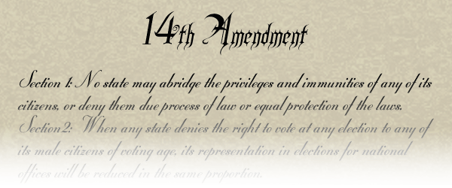 | Ratified in _______________  Guaranteed right of ________________  States could not take away ____________, ____________, or ____________  Extra Notes:
15th  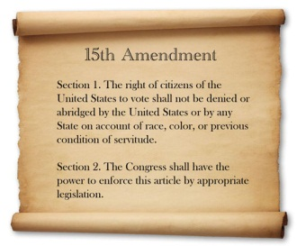 | Ratified in ____________________  Gave all men the right to ________________ no matter their  ______________ or if they had been __________________  Extra Notes:

